

**Assignment # 2**

Name: **Iman Akram**

Roll #: **SP23-BCS -056**

**Solution of Midterm Paper**

Course Instructor: **Mr. Fakhar Mustafa**

Course: **Data Science**

**COMSATS University Islamabad, Sahiwal Campus**

**Question # 2**

Creating dataset

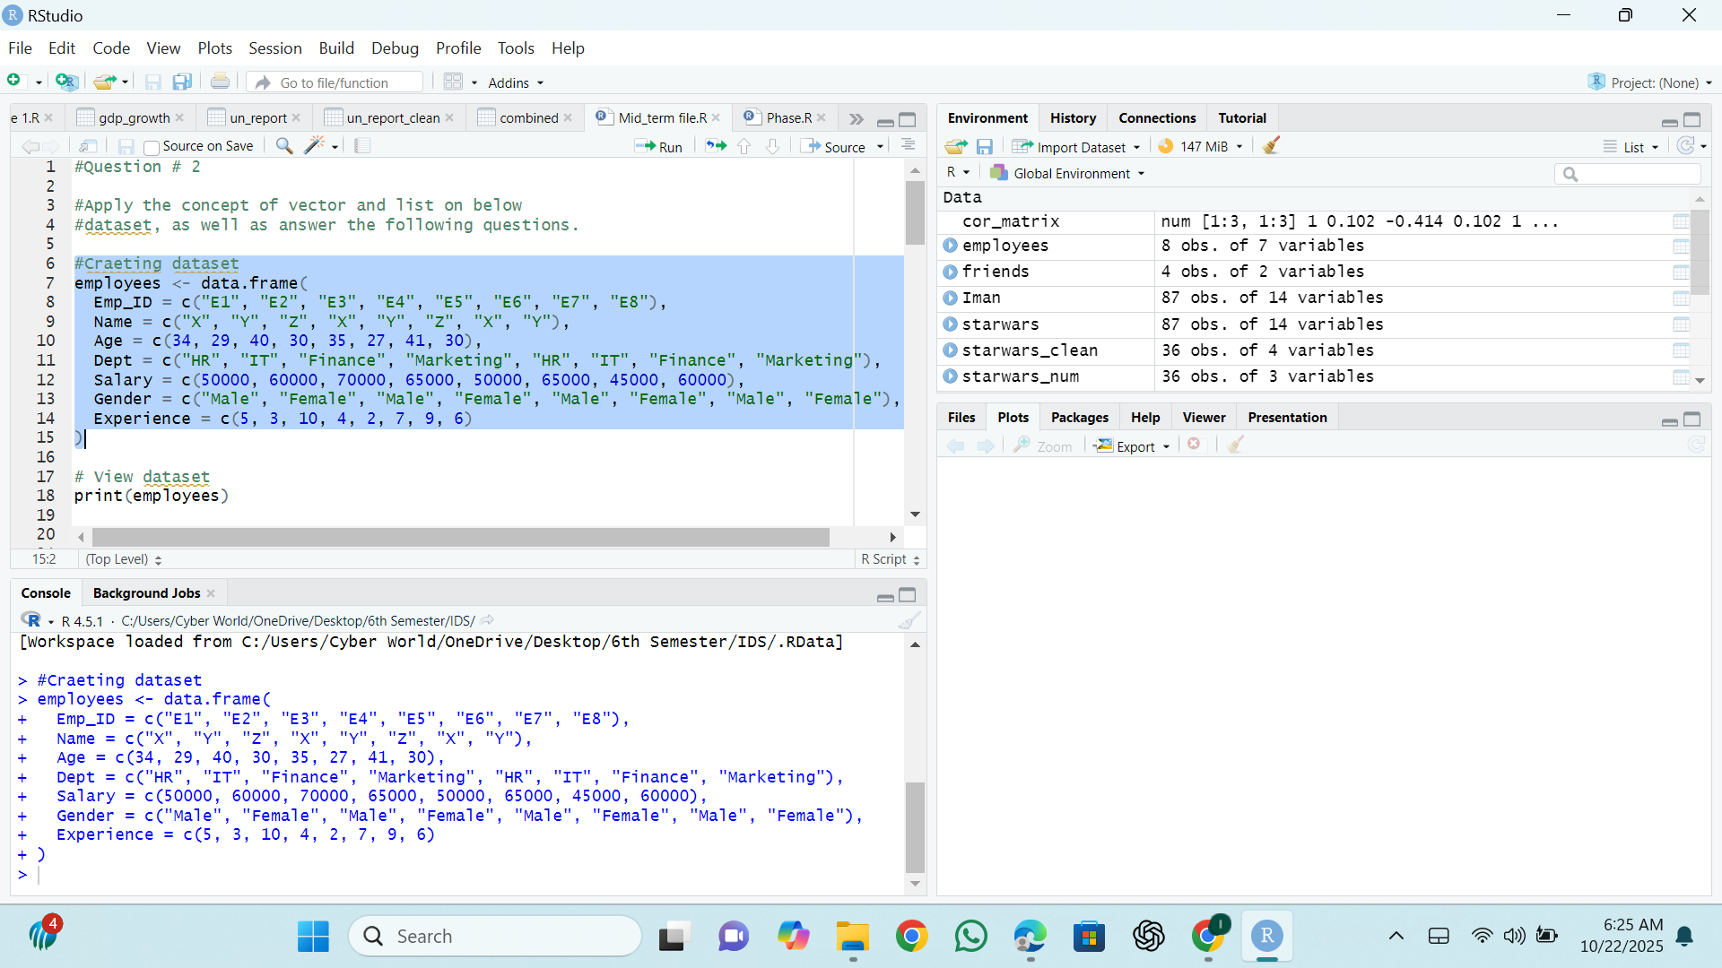

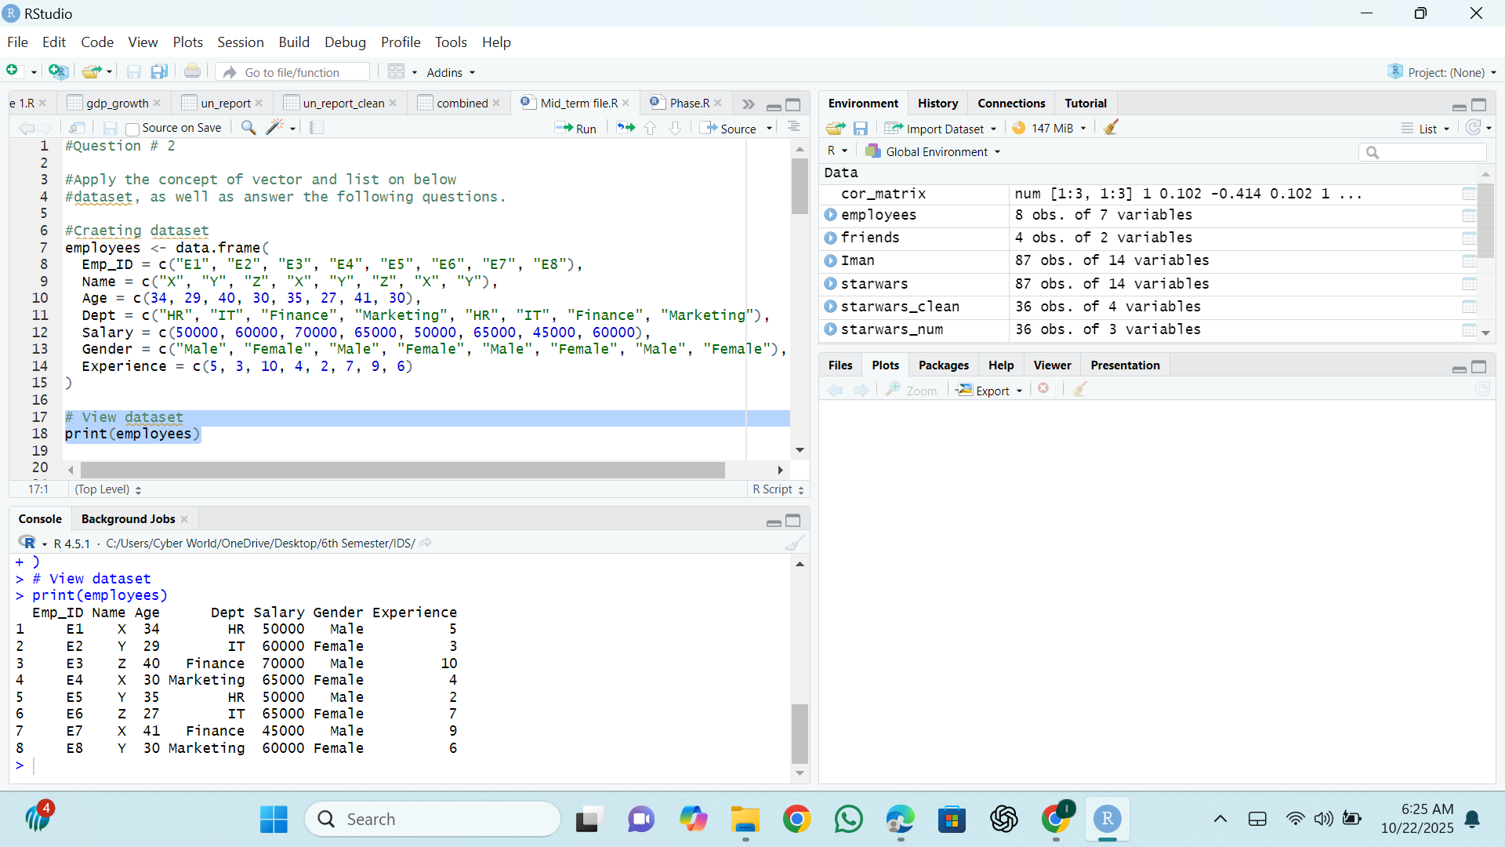Print Employees

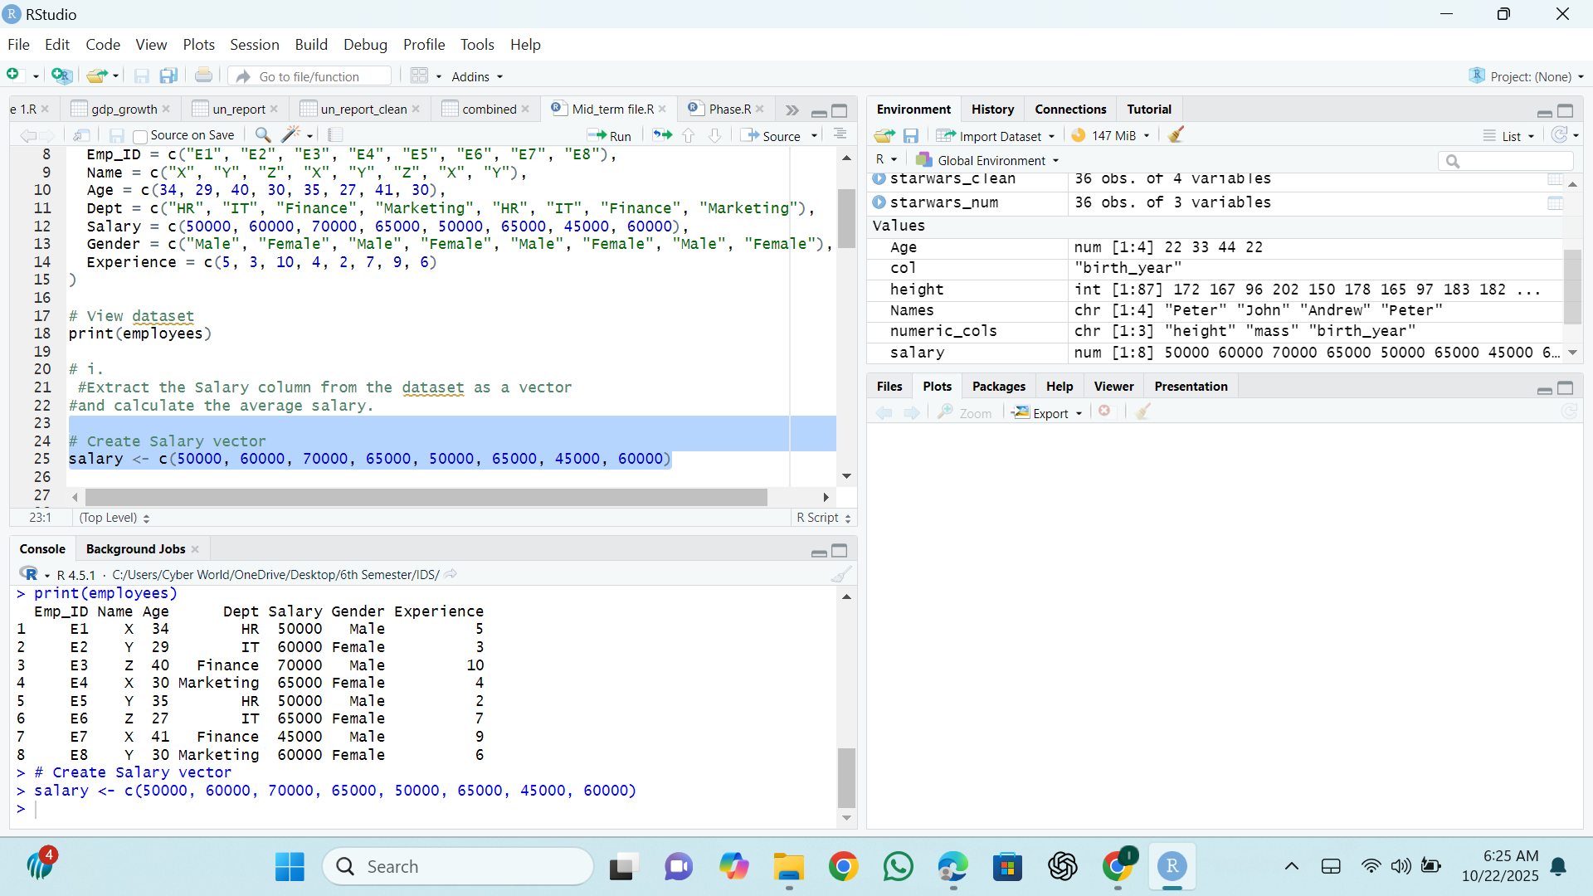Salary Vector

Calculating Average

Age Vector

Min age & Max age

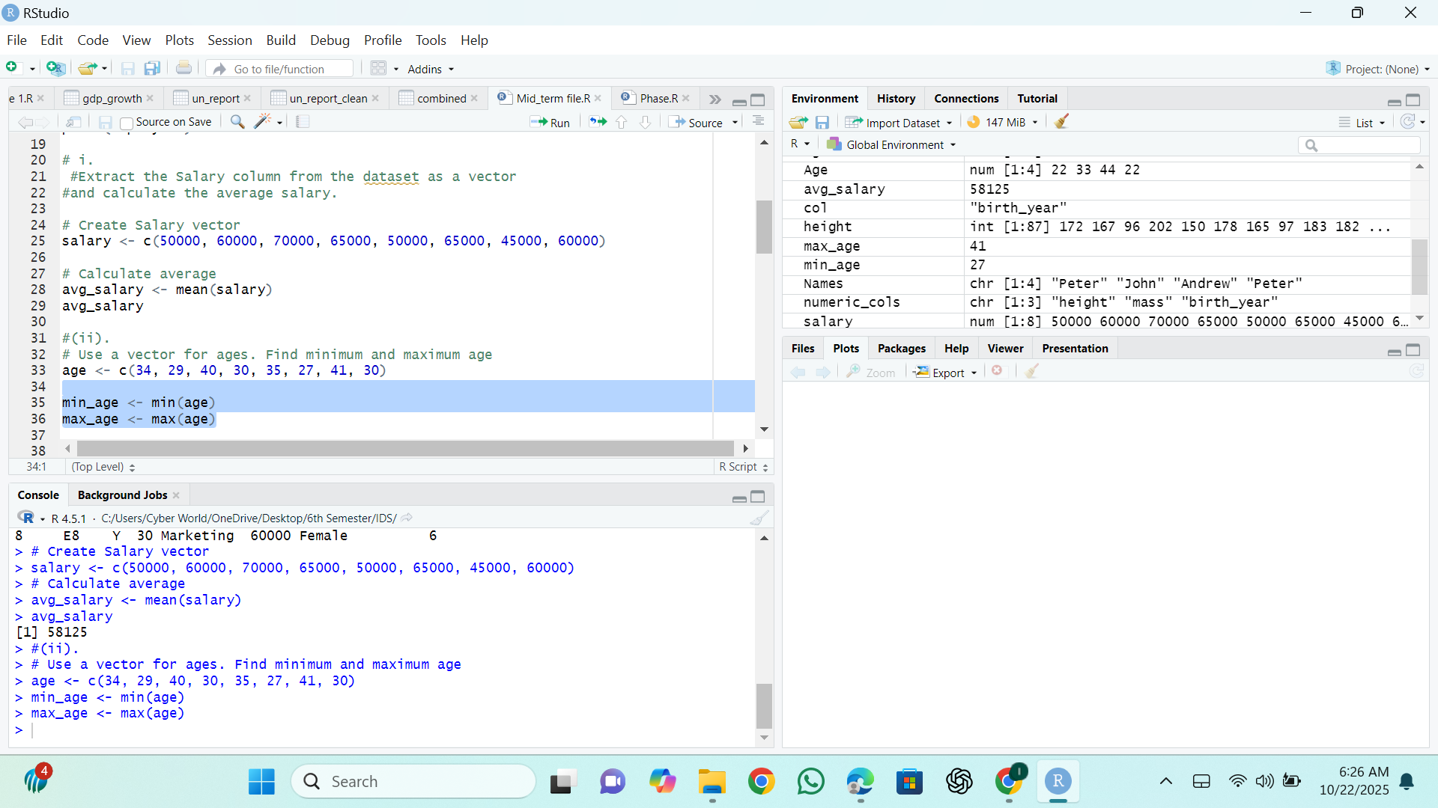

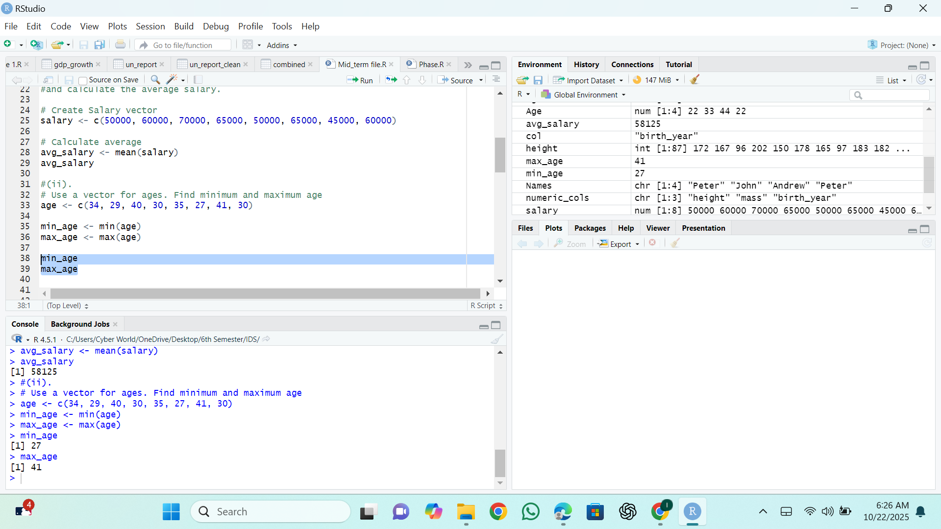View (Min age and Max age)

List for Employee

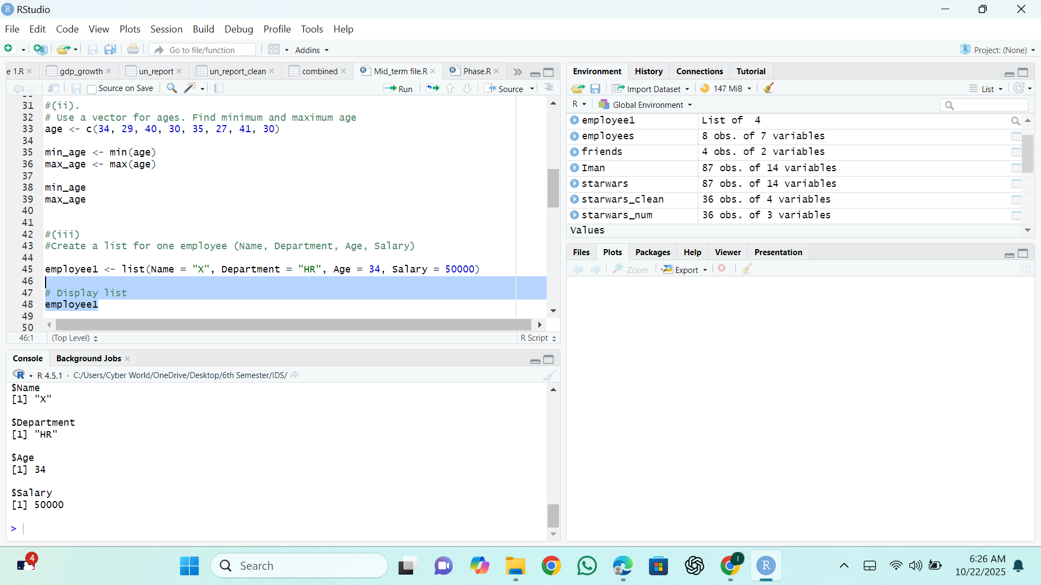Employees1

Mean, Standard deviation and correlation

**Question # 3**

Data (mtcars)

Plot

Boxplot (Cy1 and data (Miles Per gallon)

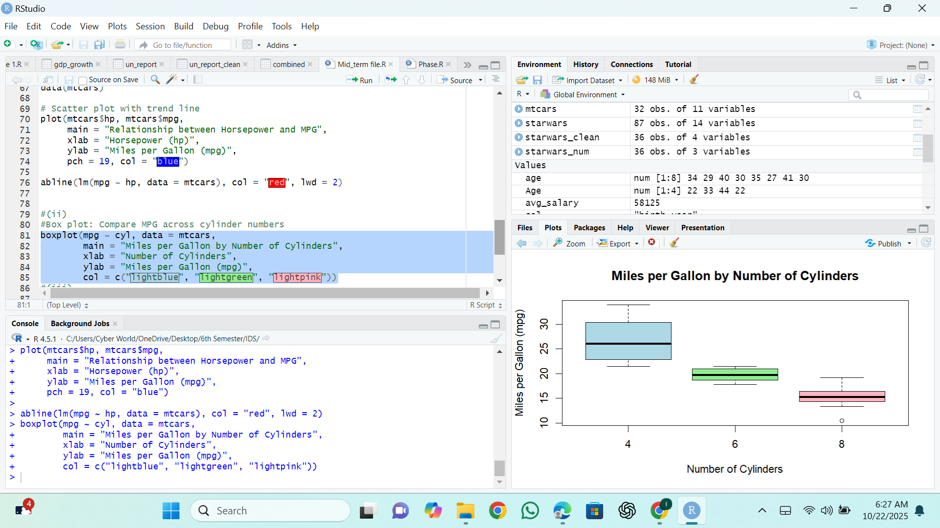

Histogram (mtcars)